## Merchant

Demo date: Sep 24, 2024  
Scoping start date: Oct 24, 2024

MSA Signature Date: Nov 25, 2024  
Onboarding Kick Off Date: Dec 5, 2024

[If Exists] Opt Out Date: none  
Go Live Date: Mar 3, 2025

GTM POC: Ben  
Implementation POC: Royce

ERP: NS

Tax Integration: No Tax

### 

### Key people at Merchant

### Director, Accounting & FP&A: Cameron Smith

### Staff Accountant: [Colette Bernsteen](mailto:cbernsteen@attainoutcomes.com)

### 

| Notes Sections [Ops International Team to Ignore] *(AE/ Implementation to fill)*   * Info on how merchant bills   + Colette manually bills today in Netsuite   + 4 main lines of business to support (We may do a phased rollout   + They have both fixed fee billing and heavily usage based billing   + The usage based billing is the majority of their business - Arjun and I spent a good amount of time scoping it out * Is there any important merchant relationship information?  1) What is the merchant temperament?   Smart and very engaged, they have a complex problem and have been diligent about tackling it.  2) Is there a key POC: (i.e.: who is the buyer/decision maker?)  Cameron was the key POC/DM, but he is buying Tabs largely for Colette and to make her job easier/scalable 3) What are the Tabs features that the key POC cares about?  Tabs being able to effectively automate their billing, which is entirely manual today and labor intensive |
| --- |

### 

### Company summary *(AE to fill)*

Attain Data, formerly known as Klover, is a Chicago-based company that operates as a commerce data platform. It provides marketers with actionable insights by leveraging consumer-permissioned first-party data (consumers voluntarily sell their data to the platform in exchange for services/discounts/benefits). The company’s goal is to create a fairer and more efficient data-sharing ecosystem that respects user privacy while offering relevant insights for advertising and marketing strategies.

**Business Model**:  
Attain collects data through a suite of consumer-facing apps that offer rewards, discounts, and financial tools in exchange for permissioned data. Klover was the first such app. This data is used for targeted advertising, consumer insights, and campaign measurement.

**Acquisitions**:  
Attain has expanded its capabilities and reach through acquisitions of additional apps:

1. **Merryfield** - A platform that promotes healthier shopping habits. This acquisition strengthened Attain's ability to provide insights into consumer health-conscious purchasing behavior​.
2. **Alliant** - An advertising data company acquired to enhance data collection and analysis capabilities, particularly for actionable marketing data​

The company is heavily focused on providing robust data solutions that adapt to the evolving digital marketing landscape, especially as third-party cookies and traditional tracking methods phase out

Goals (North star)  
*(AE/ Implementation to fill)*

What is the merchant's goal? What pain are we solving? Why are they buying Tabs?  
**Business Operations and Goals**:

* The company's largest revenue stream is categorized as **"Other,"** followed by significant activity in **Measurement**, **Affiliate**, and **Managed Services**.
* Attain is focused on scaling its **measurement side** of the business to centralize data and provide a clear revenue picture.
* Measurement will likely be the **first category** to undergo updates for usage input processes with Tabs.

**Operational Challenges**:

* **Invoice and Payment Management**:
  + Payments are manually applied, often leading to discrepancies between clients and recipients.
  + Custom fields (e.g., "Invoice Client") add complexity to cash application.
  + Currently receive notifications from AP portals sporadically.
* **Branding and Acquisitions**:
  + Legally, Clover, Merryfield, and Attain operate under the same entity but use separate DBAs.
  + Recently acquired Merryfield, introducing new operational challenges.
  + Invoices and branding are manually edited on PDFs, with a potential fallback plan to include all three logos on documents.

**Long-Term Needs**:

* **DSO (Days Sales Outstanding)** and **aging reporting**. (For Cameron)
* **Class and Department tagging** for better financial organization. (not an immediate need)

Attain's immediate focus is on aligning its growing portfolio of brands under a cohesive operational system while tackling financial and invoicing inefficiencies.

Is there an opt out clause? If so, what is the merchant looking for so they do not exercise it?  
No

### Billing model *(AE/ Implementation to fill)*

* Are there unique things about the customer creation process for this merchant?

Customers have contracts, but the contracts are not used to determine pricing when billing, that will come from the usage input

* Information on how merchant bills

Attain's billing process caters to two customer types:

1. **Fixed Fee Contracts**:
   * Revenue is based on a fixed fee for the duration of a measurement study (e.g., 1-3 months).
   * Revenue is recognized steadily over the campaign period.
2. **Usage-Based Billing**:
   * Revenue fluctuates based on ad activity, often tied to CPM (cost per thousand impressions).
   * Usage varies seasonally or by campaign (e.g., high activity for H&R Block during tax season).

* How contract is broken up

Contracts and pricing is constantly being updated - we will be invoicing based off usage input vs what is on the contracts

* One off things to know about the merchant

They do NOT have a Netsuite Sandbox. We discussed on our call and will have other ways of doing testing

### Contract Processing Steps *(Implementation/Success to fill)*

1. Steps to process:

NOTE: Merchant will be usage based only. There are no contracts due to nature of business. Will need to [upload a dummy contract](https://drive.google.com/file/d/1eQe1XaLaQWyYdgRB7VSnc0e-TAUTbtVC/view) for customers for the month’s invoice. It may be a good idea to note the month in the naming convention.

The Service start date will be the 1st of the month prior (it is billed in arrears). The item name will be ***Advertising Fees***. Item description should be ***Impressions | CPM Video: $xx | CPM Display: $xx*** - there may not always be CPM and/or the CPM may not be specific to video/display/etc. The integration item will be either Measurement Data Revenue or Managed Services. Billing type is Flat Price. Quantity is the Impressions Count (found in the file). Start date is service start date. Net terms is 30.

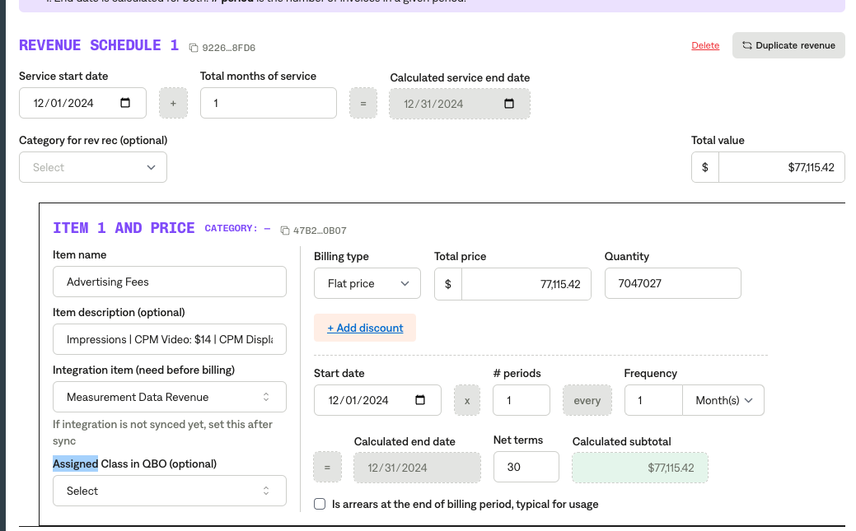

This is a sample of the file that will be shared - customer specific:

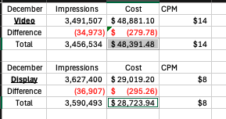  
Important - use the ***Total*** as the corresponding values for Impressions and Cost is the invoice amount.

It is possible to receive a file with multiple records. Some important fields to note:

* The Bill To Entity is the customer
* Advertiser Name is the subcustomer
* Impressions
* CPM may be ***flat-rate***. If it is flat-rate, do not include CPM in the invoice.
* Revenue is the Total Price

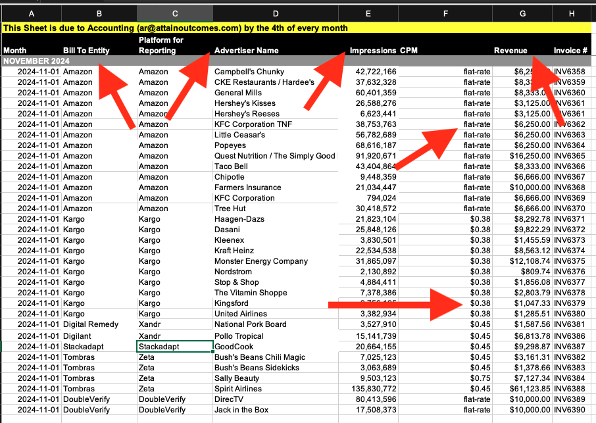

1. Anything to ignore in contracts?
2. Specifics processing things the merchant has requested that may differ by contract (e.g. always back-date invoice date to final day of the month)
3. Default Service Term
   1. 1 month
4. Default Net Payment Terms
   1. Net 30
5. Default Billing Frequency
   1. Monthly
6. How do we handle taxes as a line item?
   1. If None Listed, Ops Default is every tax line item becomes a BT

### Events Processing (if necessary) *(Implementation/Success to fill)*

* Any important information on events billing

Integration Items Processing (if necessary)  
*(Implementation/Success to fill)*

* What are the instructions for assigning integration items?
* Example: All Statsig integrations items should be labeled as “Sales”
* Example: All “Pinata” integration items should be labeled as “Software Subscription Bundle” unless otherwise noted by Merchant

Post Processing Communications (if necessary)  
*(Implementation/Success to fill)*

* Does the Ops Team need to notify anyone on the team re: completion of processing batches in Implementation or Active phase?
* Who needs to be notified and when?
  + Example:
    - Who: Customer Success [Azmat Aziz] needs to be notified
    - Where: Messari internal merchant channel
    - When: contracts are processed [Merchant Phase: Active]

### Customer Information *(Implementation/Success to fill)*

* Any important information on specifics customers of this merchant
  + Special memo’s certain invoices require
  + Invoice changes due to merchant/customer relationship

### Feature Requests *(AE/Implementation/Success to fill)*

* FR 1
  + What is it
  + Why it's important
  + Urgency

### Rewatch Calls *(AE/Implementation/Success to fill)*

* <https://tabs.rewatch.com/video/hox3d2gc8z8y9p6q-attain-tabs-reconnect-september-24-2024>
* <https://tabs.rewatch.com/video/faumoodkaf6a3k2w-tabs-attain-demo-continued-october-3-2024>
* <https://tabs.rewatch.com/video/snxbreb6rc7q2tw5-tabs-attain-scoping>
* <https://tabs.rewatch.com/video/54x6auvpkr95b3vc-hold-tabs-attain-netsuite-scoping-october-30-2024>
* <https://tabs.rewatch.com/video/ni5s24rhsuhin19m-tabs-attain-proposal-november-18-2024>